DATA MINING AND BUSINESS ANALYTICS WITH R

FdR

9 March 2015

This document intends to follow the book **DATA MINING AND BUSINESS ANALYTICS WITH R** from *Johannes Ledolter*. We are taking his work and adapting it to fit the dplyr + ggplot2 + tidyr set of libraries, as well as others when appropriate.

## Chapter 2. Processing the Information and Getting to Know Your Data

### 2.1 2006 Birth data.

We first load the library *nutshell* which contains our dataset, then load it and have a quick look at it.

library(nutshell)

## Loading required package: nutshell.bbdb  
## Loading required package: nutshell.audioscrobbler

data(births2006.smpl)  
str(births2006.smpl)

## 'data.frame': 427323 obs. of 13 variables:  
## $ DOB_MM : int 9 2 2 10 7 3 5 4 10 4 ...  
## $ DOB_WK : int 1 6 2 5 7 3 2 7 3 4 ...  
## $ MAGER : int 25 28 18 21 25 28 33 31 18 24 ...  
## $ TBO_REC : int 2 2 2 2 1 3 2 3 1 2 ...  
## $ WTGAIN : int NA 26 25 6 36 35 26 25 46 43 ...  
## $ SEX : Factor w/ 2 levels "F","M": 1 2 1 2 2 2 2 1 1 2 ...  
## $ APGAR5 : int NA 9 9 9 10 8 9 9 9 9 ...  
## $ DMEDUC : Factor w/ 18 levels "1 year of college",..: 18 4 18 18 6 18 18 4 18 6 ...  
## $ UPREVIS : int 10 10 14 22 15 18 10 19 15 13 ...  
## $ ESTGEST : int 99 37 38 38 40 39 38 38 40 40 ...  
## $ DMETH_REC: Factor w/ 3 levels "C-section","Unknown",..: 3 3 3 3 3 3 1 1 1 3 ...  
## $ DPLURAL : Factor w/ 5 levels "1 Single","2 Twin",..: 1 1 1 1 1 1 1 1 1 1 ...  
## $ DBWT : int 3800 3625 3650 3045 3827 3090 3430 3204 3227 3459 ...

head(births2006.smpl)

## DOB_MM DOB_WK MAGER TBO_REC WTGAIN SEX APGAR5  
## 591430 9 1 25 2 NA F NA  
## 1827276 2 6 28 2 26 M 9  
## 1705673 2 2 18 2 25 F 9  
## 3368269 10 5 21 2 6 M 9  
## 2990253 7 7 25 1 36 M 10  
## 966967 3 3 28 3 35 M 8  
## DMEDUC UPREVIS ESTGEST DMETH_REC DPLURAL DBWT  
## 591430 NULL 10 99 Vaginal 1 Single 3800  
## 1827276 2 years of college 10 37 Vaginal 1 Single 3625  
## 1705673 NULL 14 38 Vaginal 1 Single 3650  
## 3368269 NULL 22 38 Vaginal 1 Single 3045  
## 2990253 2 years of high school 15 40 Vaginal 1 Single 3827  
## 966967 NULL 18 39 Vaginal 1 Single 3090

Our first graph is just about the frequency of birth in function of the day of the week.

library(ggplot2)  
ggplot(births2006.smpl, aes(x = DOB_WK)) +   
 geom_bar() +   
 scale_x_discrete(labels = c("Sun.", "Mon.", "Tues.", "Wed.", "Thur.", "Fri.", "Sat."),   
 limits = c(1:7)) +   
 labs(title = "Frequency of births by day of the week",   
 x = "Day of the week", y = "Frequency")

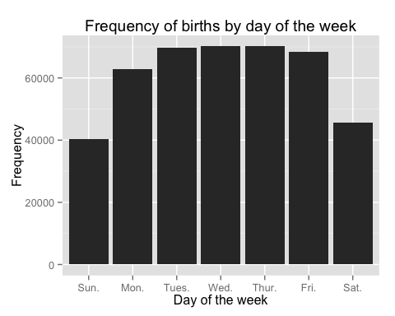

They are clearly less birth on the weekend!

Or we can segregate by method of delivery and graph it that way.

table(births2006.smpl$DOB_WK, births2006.smpl$DMETH_REC)

##   
## C-section Unknown Vaginal  
## 1 8836 90 31348  
## 2 20454 272 42031  
## 3 22921 247 46607  
## 4 23103 252 46935  
## 5 22825 258 47081  
## 6 23233 289 44858  
## 7 10696 109 34878

We first re-order the levels in the DMETH_REC variable, so that the plot look pretty normal.

births2006.smpl$DMETH_REC <- factor(births2006.smpl$DMETH_REC,   
 levels = c("Vaginal", "C-section", "Unknown"))  
ggplot(births2006.smpl, aes(x=DOB_WK, fill=DMETH_REC)) +   
 geom_bar(position="dodge") +   
 scale_x_discrete(labels = c("Sun.", "Mon.", "Tues.", "Wed.", "Thur.", "Fri.", "Sat."),   
 limits = c(1:7)) +   
 labs(title = "Frequency of births by day of the week",   
 x="Day of the week", y = "Frequency", fill = "Method of delivery")

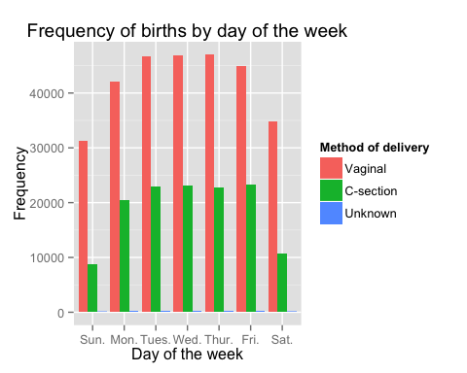

Note that the echo = FALSE parameter was added to the code chunk to prevent printing of the R code that generated the plot.